**Cloud computing service models**

* **Ashwin Harish P**

There are 4 types of service models

1. On-premises
2. IaaS(Infrastructure as a Service)
3. PaaS(Platform as a Service)
4. SaaS(Software as a Service)

**On-Premise**

On-Premise refers to a traditional IT model where all software, hardware, and infrastructure are physically located within the organization’s own premises (like in their office, data center, or private server room). The company is fully responsible for managing, securing, and maintaining these systems.



**Components Managed in On-Premise Setup:**

1. **Hardware**: Physical servers, storage systems, networking equipment.
2. **Infrastructure**: Power supply, cooling systems, cabling.
3. **Software Stack**: Operating systems, databases, middleware, applications.
4. **Security**: Firewalls, antivirus, intrusion detection — all managed internally.
5. **IT Staff**: Required for setup, monitoring, troubleshooting, patching, and upgrades.

**Use Case:**

TaxSmile is a tax filing platform. Peak usage occurs between April–August (IT returns season).

**Base Setup**: 2 servers in place for regular operations.

**Additional Load Requirement (Feb)**: Load testing indicates the need for **3 more servers**.

**Provisioning Process** (complex & time-consuming):

* 1. **Approvals**: Needed from Directors, CTO, COO.
  2. **Procurement**: Buy servers from Germany (takes 2 weeks).
  3. **Installation & Setup**:
  4. **Power Supply** setup.
     + Network Engineers required 24/7.
     + Involves 3 internal teams + 1 external team (Hexaware).
     + Significant coordination and CTC involved.
  5. **Rent** for the physical server room.

For the non-peak months, I can’t send the 2 servers back to Germany. This is the problem with on Premise solution

**IaaS**

IaaS is a cloud computing service model that provides virtualized computing infrastructure over the internet. Instead of buying and maintaining physical servers, organizations rent IT infrastructure — servers, storage, networking, and virtualization — from a cloud provider on a pay-as-you-go basis.

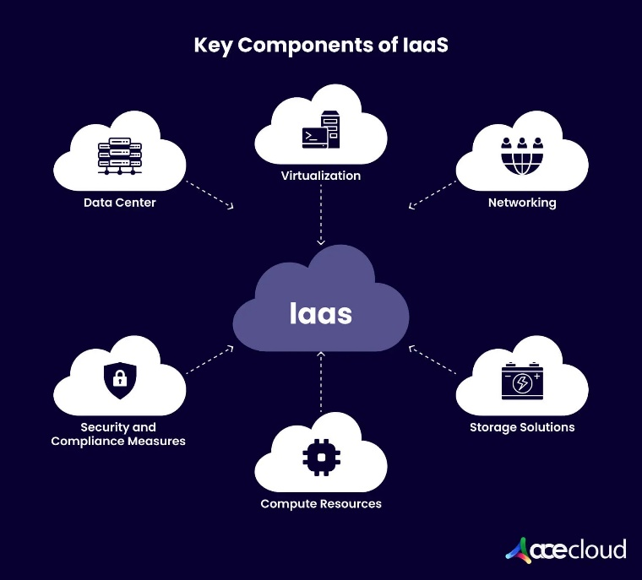

**Key Characteristics of IaaS:**

* **Scalability**: Instantly scale resources up or down based on demand via UI or APIs.
* **Flexibility**: Choose your own operating system, storage type, networking rules, and applications.
* **Control**: You manage and control the OS, middleware, applications, and data — but not the physical hardware.
* **Pay-as-you-go**: Pay only for the compute, storage, and network resources you actually use.
* **No Physical Hardware**: No need to buy, install, or maintain physical servers — the cloud provider handles that.
* **Global Availability**: Deploy infrastructure in different geographic regions and availability zones.
* **Shared Security Responsibility**: The provider secures the infrastructure; you are responsible for your OS, apps, and data security.

**Common IaaS Providers:**

* **Microsoft** – Azure Virtual Machines
* **Amazon** – Amazon EC2 (Elastic Compute Cloud)
* **Google** – Google Compute Engine
* **IBM** – IBM Cloud Infrastructure
* **Oracle** – Oracle Cloud Infrastructure (OCI)

**Pros of IaaS:**

* No hardware maintenance
* Highly scalable and flexible
* Global reach with cloud zones and regions
* Pay-as-you-go pricing

**Cons of IaaS:**

* You still need to manage OS, patches, and application updates
* Security responsibility is shared (you handle data and app-level security)
* Can become expensive if not monitored properly

**PaaS**

PaaS (Platform as a Service) is a cloud computing service model that provides a platform and environment for developers to build, deploy, and manage applications without dealing with the underlying infrastructure (servers, storage, networking, OS). The provider manages most of the backend, so developers can focus on writing code and business logic.

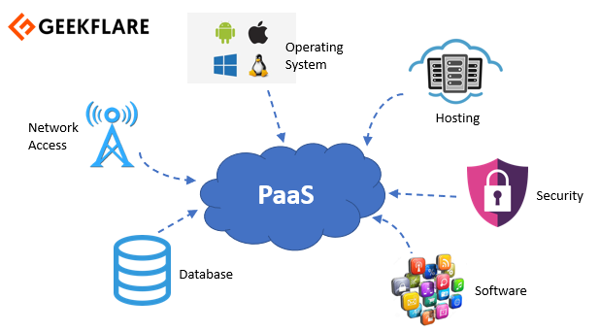

**Key Characteristics of PaaS:**

* **Developer-Friendly**: Provides tools, frameworks, and runtime environments to accelerate development.
* **Managed Infrastructure**: No need to manage OS, hardware, or middleware — the provider handles it.
* **Built-In Scalability**: Automatically scales based on traffic or demand.
* **Integrated Services**: Offers built-in services like databases, authentication, caching, etc.
* **Faster Time to Market**: Focus on app development, not system configuration.
* **Lower Maintenance**: Minimal admin tasks compared to IaaS.

**Common Paas Providers**

• **Microsoft** – Azure App Service  
• **Google** – Google App Engine  
• **Amazon** – AWS Elastic Beanstalk  
• **Heroku** – Cloud platform for deploying apps  
• **Red Hat** – OpenShift

**Pros of PaaS:**

• Focus purely on development and innovation  
• Faster application deployment  
• No need to manage OS, middleware, or servers  
• Auto-scaling and built-in integrations

**Cons of PaaS:**

• Less control over the underlying infrastructure  
• Possible vendor lock-in (tied to a specific provider’s environment)  
• Limited customization compared to IaaS  
• May not support legacy systems easily

**SaaS**

SaaS (Software as a Service) is a cloud computing model where users access fully functional software applications over the internet, typically through a web browser. The provider manages everything — from infrastructure to software updates — and the user simply consumes the service.

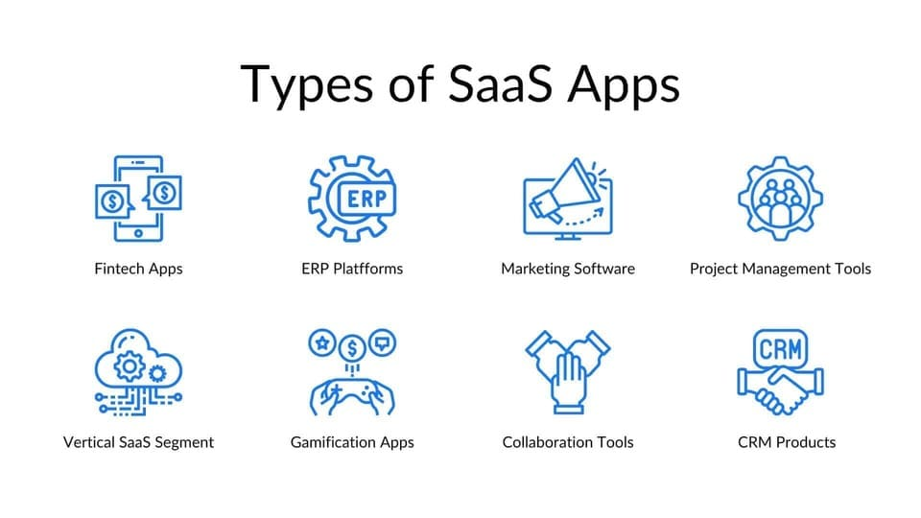

**Key Characteristics of SaaS:**

* **Fully Managed by Provider**: You only use the application — everything else is taken care of.
* **Accessible via Web**: No installation needed; just log in and start using.
* **Subscription-Based**: Usually follows a monthly or yearly pricing model.
* **Automatic Updates**: Always up to date with the latest features and security patches.
* **Device Independent**: Access from any device with an internet connection.
* **Multi-Tenant Architecture**: A single instance serves multiple users.

**Common SaaS Providers:**

• **Google** – Gmail, Google Docs  
• **Microsoft** – Office 365  
• **Salesforce** – CRM software  
• **Dropbox** – Cloud storage  
• **Zoom** – Video conferencing  
• **Slack** – Team communication tool

**Pros of SaaS:**

• No installation or maintenance needed  
• Quick to start and easy to use  
• Accessible from anywhere  
• Lower upfront cost  
• Automatic backups and updates

**Cons of SaaS:**

• Limited customization  
• Requires stable internet connection  
• Concern over data security and privacy  
• Subscription fees can add up over time

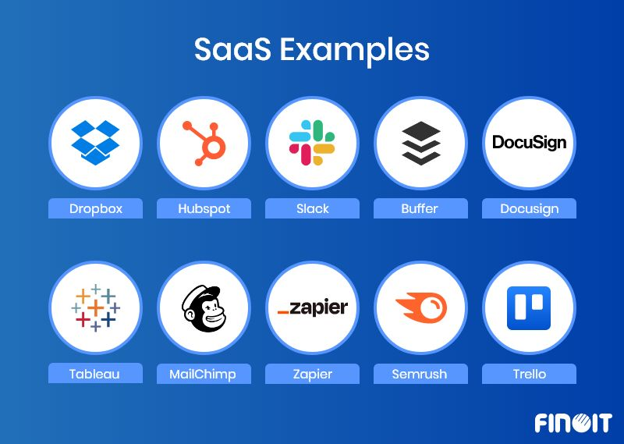

**Comparison**

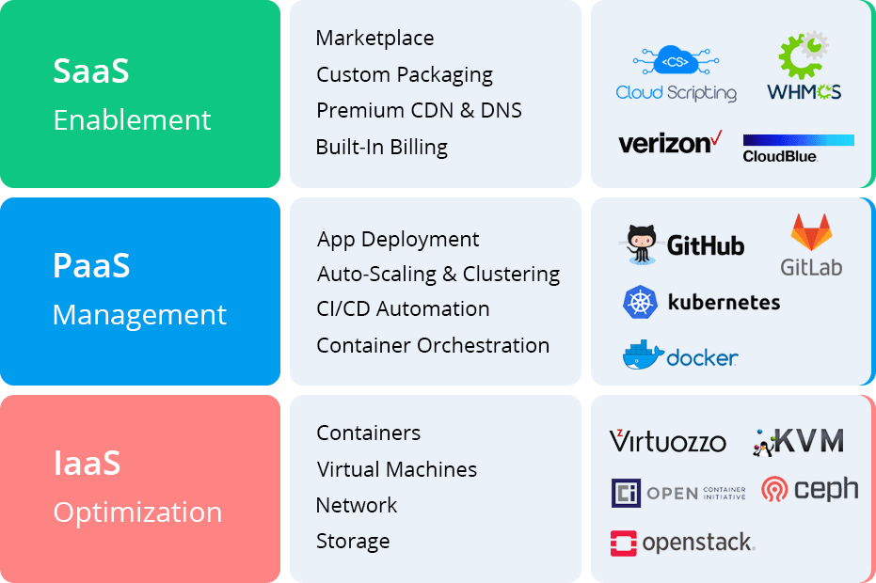

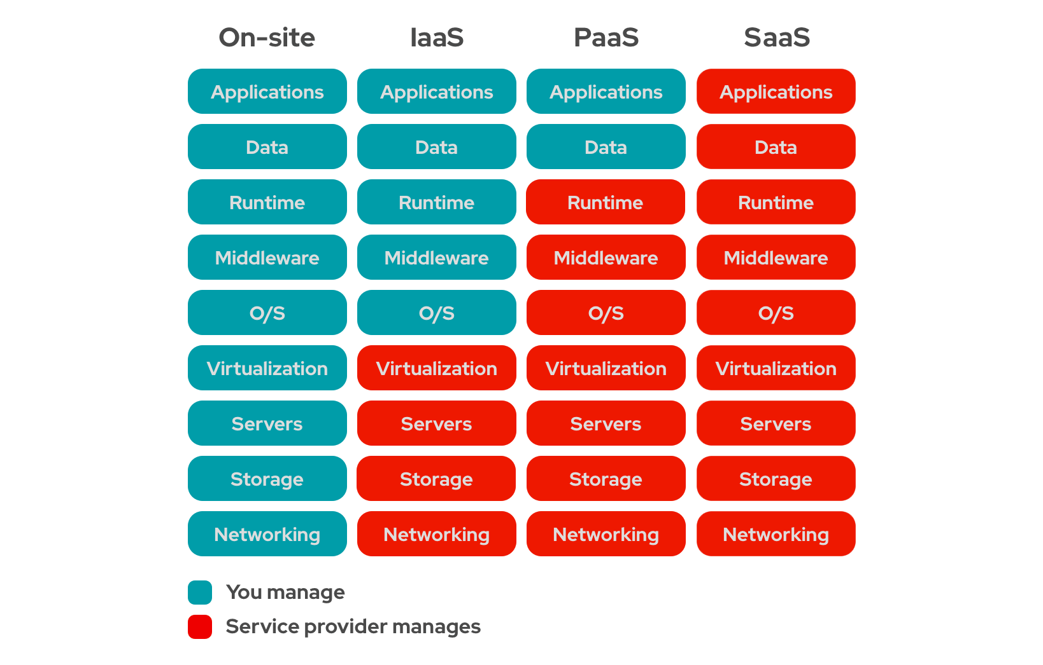

**On-Premises:**  
Physical servers managed by the organization itself, such as Hexaware’s own data center infrastructure.

**IaaS (Infrastructure as a Service):**  
Example: Azure. You get virtual machines where you need to install and manage the operating system, Python interpreter, and any required packages like PySpark yourself. You are also responsible for managing components like load balancers.

**PaaS (Platform as a Service):**  
Example: Google Colab. The platform takes care of managing the underlying infrastructure, runtime, and software environment, so you can focus solely on writing and running your code without worrying about installation or maintenance.

**SaaS (Software as a Service):**  
Examples: Google Teams, Google Meet. These applications run entirely on the cloud and can be accessed directly through a web browser without any installation. All maintenance and updates are handled by the service provider.